Flexible Position Control - FPC

Report Open Reqs. by Skill Mix Add Hired-In FTEs
Version 1.0
Updated: 2//2023 :00 AM


Contents
Contents 2
Version History 3
Current Version Approval History 3
1 Overview 4
1.1 Background 4
1.2 Proposals 4
1.3 Assumptions, Constraints, and Dependencies 4
2 User Stories 5
2.1 FPC Division and Facility Reports – Open Reqs by Skill Mix Add FTEs column 5

Version History
Version | Modifier | Modified | Comment
1.0 | Lauri Olsen | 04/01/2026 | Initial Draft

Current Version Approval History
Role | Approver | Approved | Comment
Business Liaison
Product Manager

Overview

Background
Today, both the Division Level and Facility Level FPC Report Open Reqs by Skill Mix does not show the FPC Plan’s Hired-In FTEs total value.

The business is asking that the FPC Report Open Reqs by Skill Mix has the Hired-In FTEs total value added into both the Division Level and Facility Level FPC Reports so that Users have that reference available when evaluating the Report’s data.

Proposals
Scope: FPC will
- Within the Division Level and Facility Level Reports
  - Add a column showing the Department Plan’s Total Hired-In FTEs value from the Plan

Assumptions, Constraints, and Dependencies
- Assumptions:
  - List unless N/A
- Constraints:
  - List unless N/A
- Dependencies:
  - List unless N/A

User Stories

FPC Division and Facility Reports – Open Reqs by Skill Mix Add FTEs column

Narrative
As an FPC Report User, I need both my Division Level and Facility Level FPC Open Reqs. by Skill Mix Reports to show each Department Plan’s Total Hired-In FTEs in a column so I have further information to assist in my Plan’s evaluation.

Activity Steps
- Navigate to ISAS/FPC/Reports
  - Run Division Open Reqs. by Skill Mix Variance Report
  - Run Facility Open Reqs. by Skill Mix Variance Report
- Observe the new column “Hired-In FTEs”

Acceptance Criteria
- User sees, within the existing Column Grouping “ Paid FTE's Core”, a new column is added directly to the right of the “Net Req.” column
  - Column Label
    - Hired-In FTEs
  - Displays the FPC Department Plan’s
    - Total Hired-In FTEs value
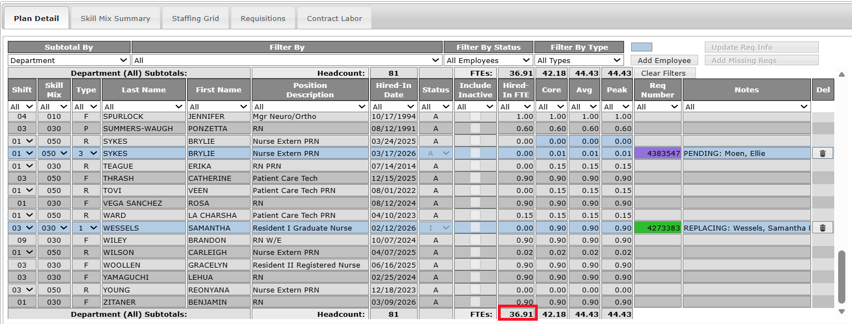
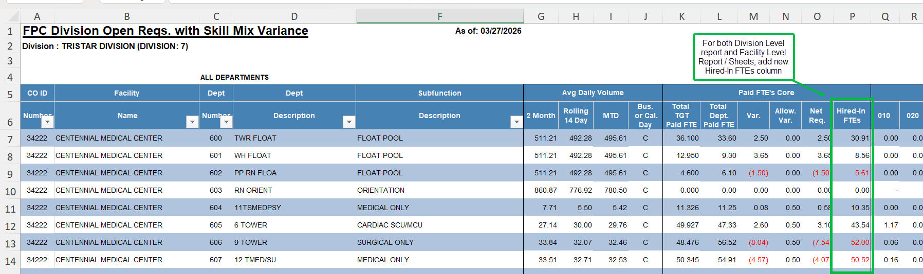
Report Example:

